Title or Task: | Copyright    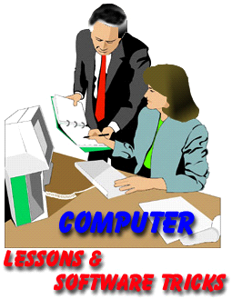

Description:

Files Required
Suitable for Classes: | AIT • Multimedia • Cert II IT • Cert II Bus
Area: | Technology & Enterprise
Teacher: | Mr Peter Faulks

Timeline

Date Due:
Task Brief: | In class lesson

Outcomes:

Items highlighted in yellow are tasks for you to complete
Items in Blue italics are help tips

These pages are designed to show you how to use software packages; various software updates may have taken place so some pages will not apply to versions other than those listed here. In some cases data files may be required.

Copyright Law

Questions what is/are

1 Copyright Laws

Answer:

2. Internet Ethics

Answer:

3 Educational Controls

Answer:
4 Health Issues

Answer:
5 Emerging Technologies

Answer:

6 Look up Copyright law and apply it to
Answer:

a. A published article that you may write

b. A drawing you created

7 Copyright Law and How it Works
Answer:

Everything original that you write (or draw or paint or whatever), regardless of whether it is an email, a painting, an image, a thesis, a web page, a paragraph on a forum, or anything else is automatically copyright protected by you. It does, of course, have to be recognizable as an original work. Thus, the word "the" in a forum would hardly qualify. The exceptions generally must be spelled out in a contract that is agreed upon. For example, Webmasterworld's Terms Of Service (TOS) modifies the copyright to both webmasterworld and the original author.

Save the work



